## UI Design – Personal Portfolio Site

### Requirements

* Portfolio website must be accessible over the internet
* The layout must be responsive; adapts to PC and smartphone screen ratios
* Must be a static website to reduce complexity and costing
* Must present developer contact information on a dedicated page
  + This page must include a link to download the developer’s CV
* Must include information on a variety of the developer’s projects
  + Presents ‘cards’ for individual projects
  + Cards link to project-specific writeup pages
  + A selection of cards must be presented on the home page
  + A dedicated projects page must feature all cards

### Wireframes

#### Home Page

The home page presents a photo of the developer, alongside their name and a short description about their personality and interests. Below, a selection of project cards are then presented underneath a header, with a call-to-action button overlain for viewing more projects – which navigates to the projects page.

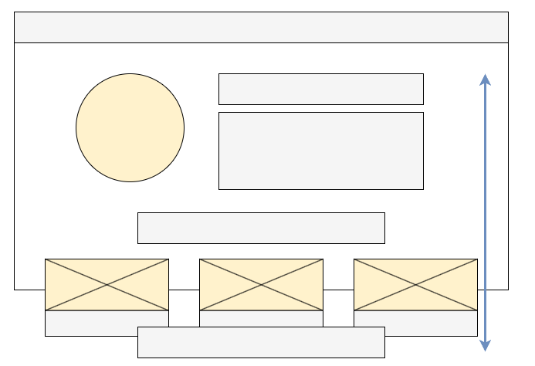

Figure - Home Page wireframe (desktop)

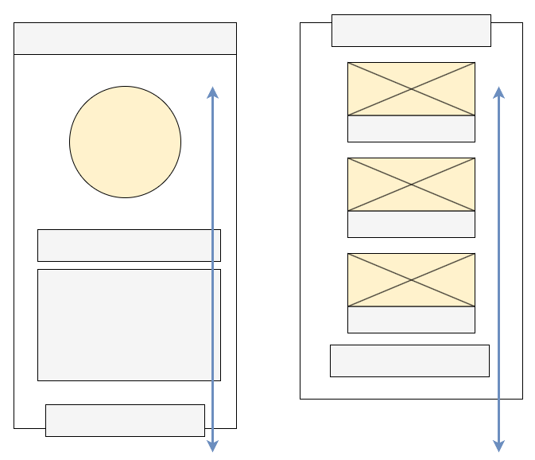

Figure - Home Page wireframe (mobile)

#### Projects Page

This page presents the full selection of project cards, each of which link to project-specific writeup pages. To navigate to other pages, the app bar can be used (top of the page).

Figure - Projects page wireframe (desktop)

Figure - Projects page wireframe (mobile)

#### Project Writeup Page

Project writeup pages will vary with the projects themselves. They should be familiar to markdown documents – simple pages with headings, links and images.

Figure - Project Writeup page wireframe (desktop)

Figure - Project Writeup page wireframe (mobile)

#### Contact Page

The contact page again presents a photo of the developer, alongside their contact details. Additionally, the user should have the option to download the developer’s CV from this page (presented as a button).

Figure - Contact Page wireframe (desktop)

Figure - Contact Page wireframe (mobile)